Complete the following tasks and provide a screenshot when required.

- Register online for CCI Linux/Oracle account

1.A. Request your Linux/Oracle Account: https://linux.cci.drexel.edu/signup/

Setup a password for Linux/Oracle Account (in the "iSchool Accounts" section of the request form) different than your DrexelOne Password, and remember clearly.

Linux/Oracle/iSchool Passwords MUST:
- Only contain alphanumeric characters (a-z A-Z 0-9).
- Letters and numbers only, in other words.
- Begin & end with a letter.
- Contain at least a couple numbers in them.
- Be between 8-12 characters in length.

1.B. Refer to the User Documentation about "How to connect to Linux and then Oracle":
https://linux.cci.drexel.edu/docs/

Basically, the steps are:

a. Open a terminal (Windows: Command Prompt (i.e. cmd) & Mac: Terminal)

For Windows user: Open the Command Prompt (i.e. cmd) by typing "cmd" into the search bar (or the Windows Start icon); For Mac user: Open the Terminal by typing "terminal" into the search bar of the Launchpad;

b. Execute: ssh abc123@linux.cci.drexel.edu
(replace 'abc123' with your Drexel user id to login CCI Linux server)

If it is your first time connecting, type "yes" to the authenticity question "Are you sure you want to continue connecting (yes/no)?"

c. Provide your password of Linux/Oracle Account (as you've setup during the account request)

d. On Linux, execute: sqlplus abc123@ike
(replace 'abc123' with your Drexel user id to login CCI Oracle server)

e. Provide your password of Linux/Oracle Account again

f. Run the following query to test your Oracle connection:
SQL> SELECT * FROM hc848.TEST_ORACLE_CONNECTION;

(It MUST result your username and the status = “Connected”)

If you require any other assistance about your Linux/Oracle account, contact the iCommons by emailing ihelp@drexel.edu

1.C. Screenshot (3 points)

Include here a screenshot showing that you were able to connect to Oracle using sqlplus and run the SQL above.
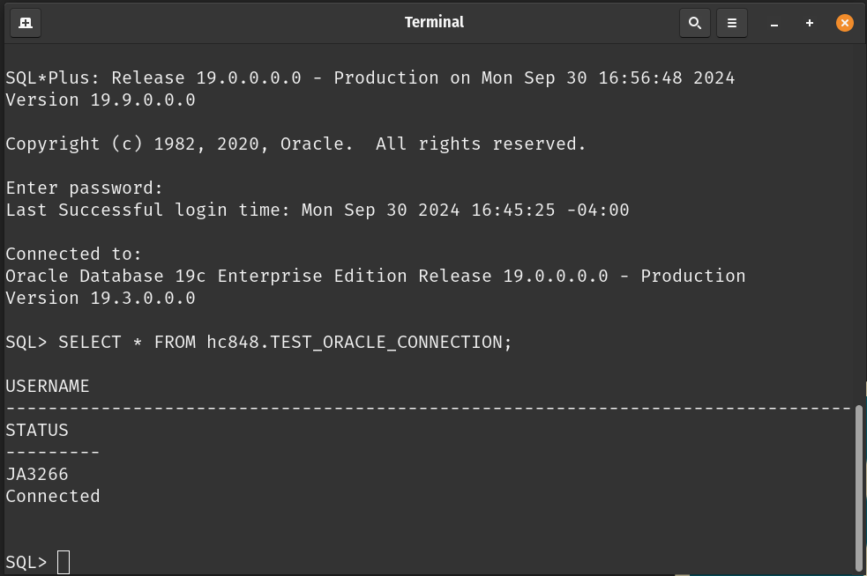

- Download Oracle SQL Developer

2.A. From the following link, choose "with JDK 11 included"
  - https://www.oracle.com/tools/downloads/sqldev-downloads.html
- IF you have issues running with JDK 11, you can try this link that uses JDK 8:
  - https://www.oracle.com/tools/downloads/sqldev-downloads-2120.html
- You don't need to "install", just unzip the files, and run:
  - sqldeveloper.exe (Windows) OR
  - sqldeveloper.sh (Other OS)
- Then:
  - Right-click "Oracle Connections" and choose "New connection"
    - Name: CCI Oracle
    - Username: <your abc123 username>
    - Password: <your Oracle Database password provided by CCI>
    - Check "Save Password"
    - Hostname (lowercase): oracle2.cci.drexel.edu
    - Port: 1521
    - SID (lowercase): orcl
  - Click "Save"
  - You must see now "CCI Oracle" in the list of "Oracle Connections"
  - Right-click "CCI Oracle" and choose "Connect" to open a connection with the database
*** You MUST be connected to the internal Drexel network (or Drexel VPN), otherwise your connection will NOT work – Check the following link if you need instructions how to connect to Drexel VPN ***
https://drexel.edu/it/help/a-z/VPN/

2.B. Then, run the same query to test your Oracle connection (use the Run Statement button ):
SELECT * FROM hc848.TEST_ORACLE_CONNECTION;

(It MUST result your username and the status = “Connected”)

2.C. Screenshot (4 points)

Include here a screenshot showing that you were able to connect to Oracle using Oracle SQL Developer and run the SQL above.
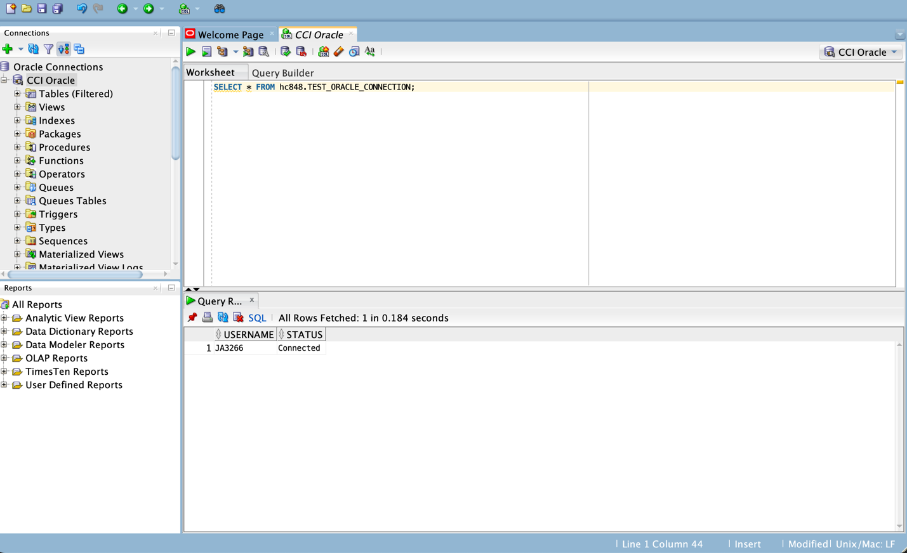

- Create your free academic account at vertabelo.com

- Go to https://my.vertabelo.com/sign-up/create-academic
- Check “Student”
- Make sure you use your Drexel email (abc123@drexel.edu) to create your account

Find further instructions here:
https://support.vertabelo.com/en/knowledge-bases/2/articles/305-how-to-register-for-an-academic-account

I will share with all students a document named:
“INFO-365 - Synthetic Clinical Patient Database (SQL Review)”

Screenshot (3 points)

Open the document above and include here a screenshot from vertabelo.com showing that you can see the definition for NITRE_* tables.

*** If you don’t have access to the shared document, send an email to your instructor to request access ***
